Assignment no.7

Create Emp table, insert data into table.

|  |  |  |  |  |  |
| --- | --- | --- | --- | --- | --- |
| **Empid** | **EmpName** | **Department** | **ContactNo** | **EmailId** | **EmpHeadId** |
| 101 | Isha | E-101 | 1234567890 | [isha@gmail.com](mailto:isha@gmail.com) | 105 |
| 102 | Priya | E-104 | 1234567890 | [priya@yahoo.com](mailto:priya@yahoo.com) | 103 |
| 103 | Neha | E-101 | 1234567890 | [neha@gmail.com](mailto:neha@gmail.com) | 101 |
| 104 | Rahul | E-102 | 1234567890 | [rahul@yahoo.com](mailto:rahul@yahoo.com) | 105 |
| 105 | Abhishek | E-101 | 1234567890 | [abhishek@gmail.com](mailto:abhishek@gmail.com) | 102 |

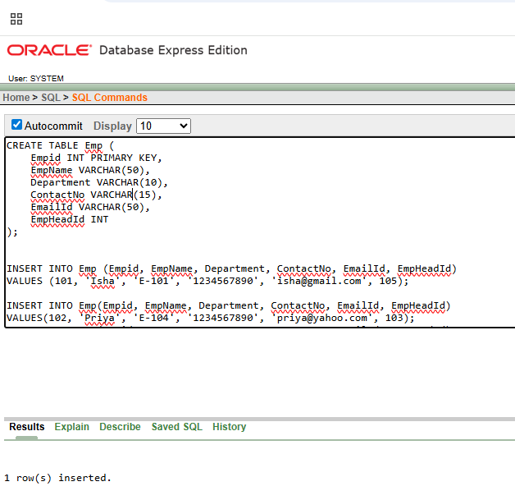

Query:

1. Display all records from table.

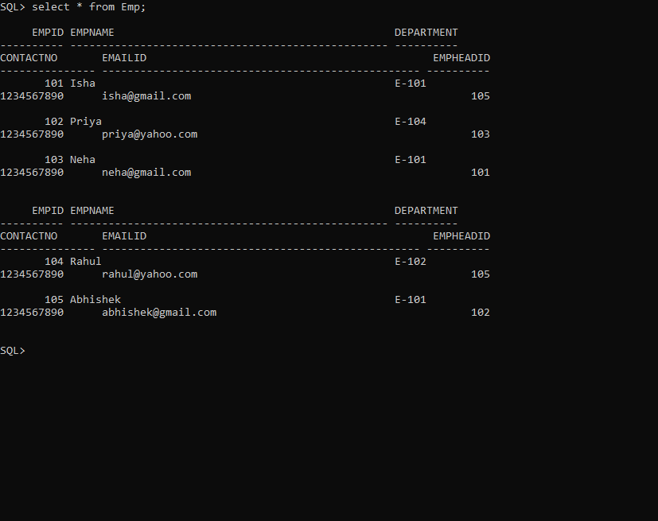

1. Display All details of employees whose EmpHeadId is greater than 102.

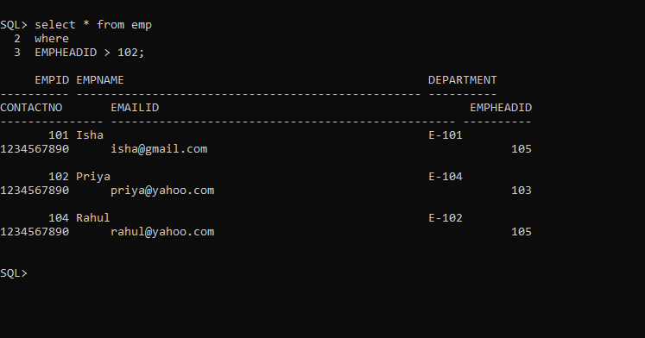

1. Display EmpID, EmpName from table.

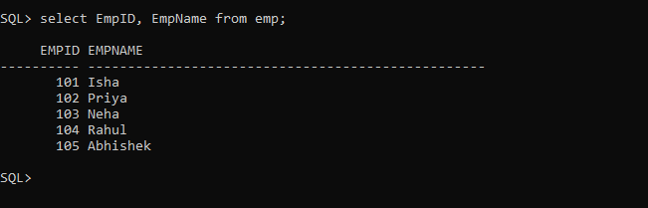

1. Change contact no of Priya to 0123456789

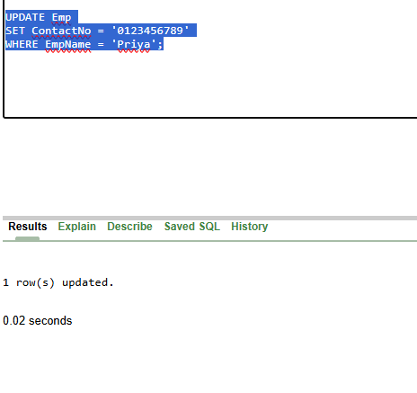

1. Display records in descending order by their name.

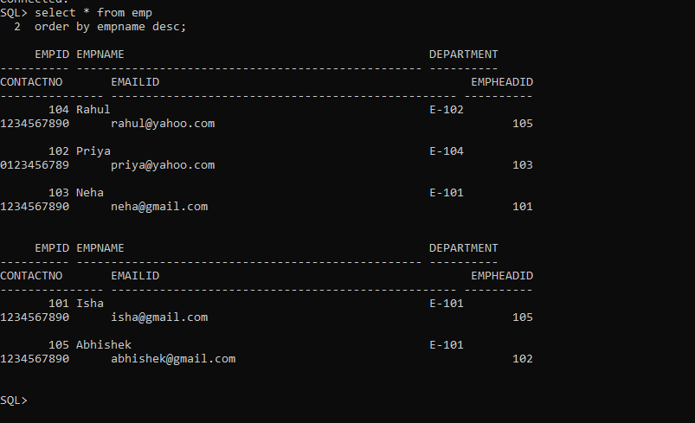

1. Display the detail of employee whose name start with P.

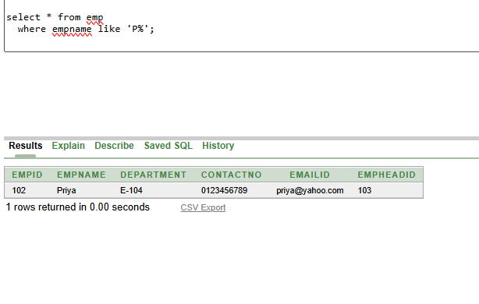

1. Display Empid, Empname and Emailid of employees whose emailId is In gmail.

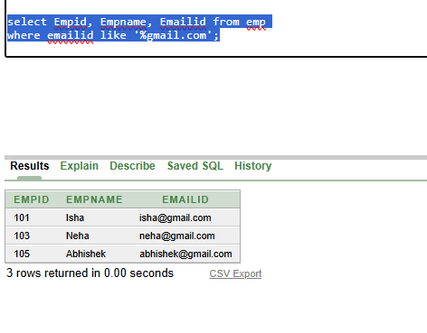

1. Display details of the employee who work either for department E-104 or E-102.

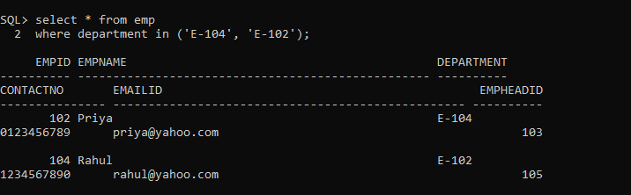

1. List name of all employees whose name ends with a.

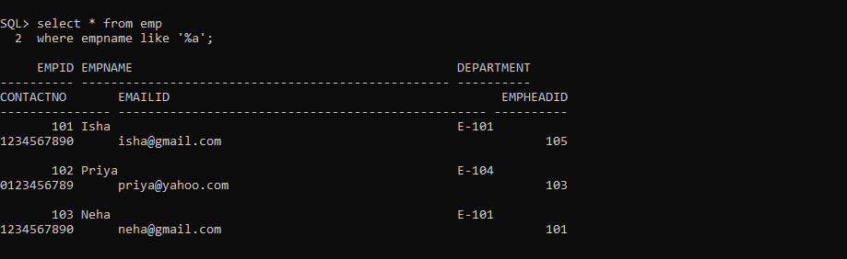

1. Display the name of the employee whose name's 3rd character is 'h'.

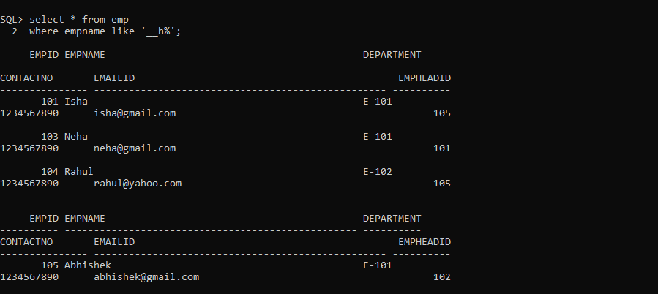

1. Display details of the employee whose Empid is 104 & EmpHeadId is 105.

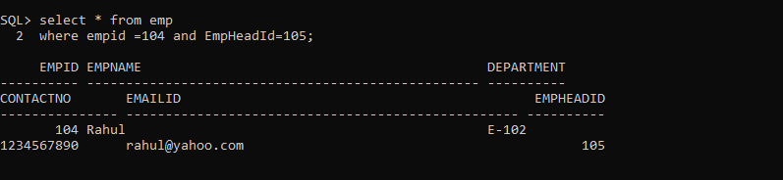

1. Create one duplicate table and delete all the records from duplicate table.

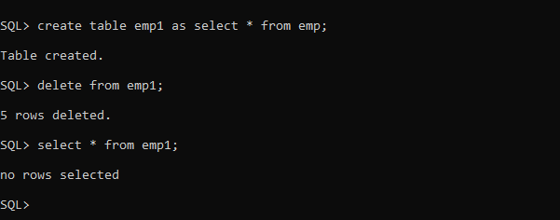

1. Delete all the records of employees who works in department E-101.

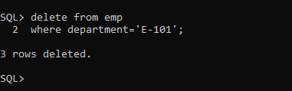

1. Truncate table emp.

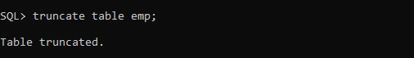

2. Create table customers with appropriate Data types and Insert following Data



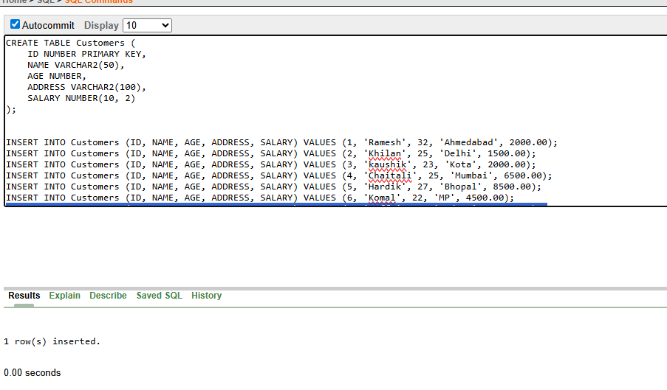

1. all the details of all the Customers.

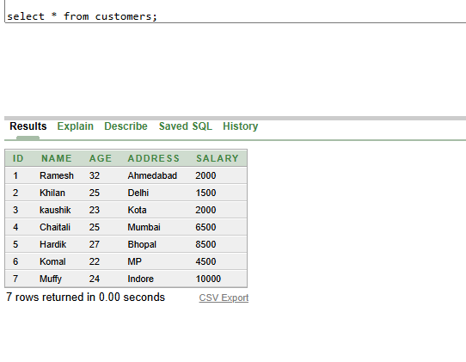

1. Display Name and Age of all Customers

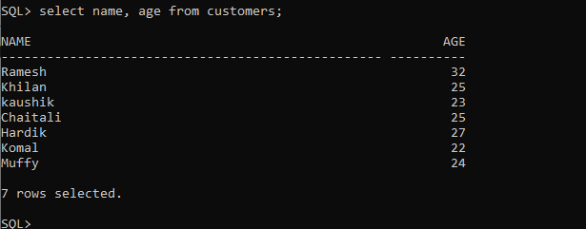

1. change salary of Kaushik to 25000.

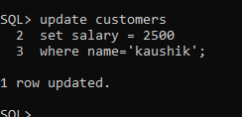

b) All the details of Customers who lives in Mumbai.

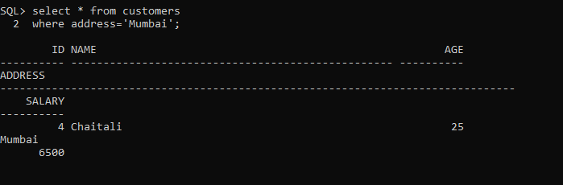

c) Details of Customers whose age is less than 25 and salary greater than 3000.

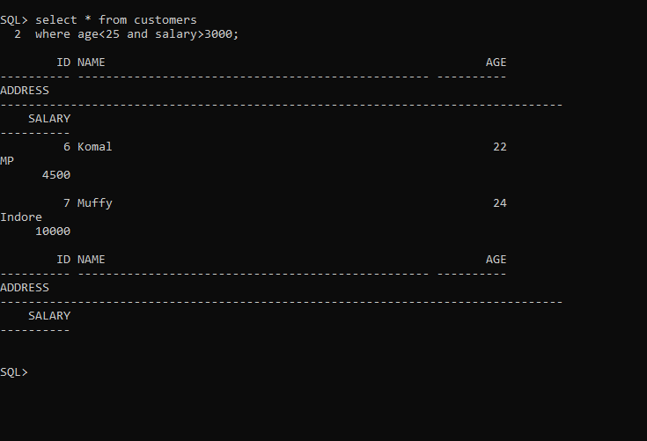

d) Name of all Customers who lives in Bhopal or whose salary is less than 4000.

